**Java PriorityQueue**

The PriorityQueue class provides the functionality of the heap data structure.

It implements the Queue interface.

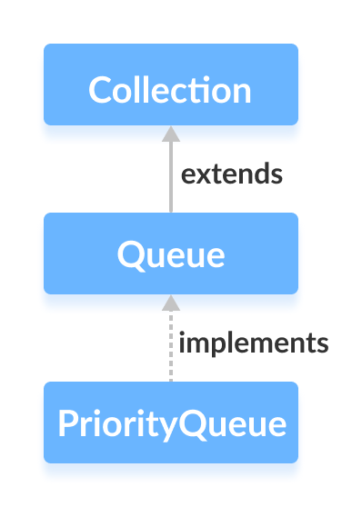

Unlike normal queues, priority queue elements are retrieved in sorted order.

Suppose, we want to retrieve elements in the ascending order. In this case, the head of the priority queue will be the smallest element. Once this element is retrieved, the next smallest element will be the head of the queue.

It is important to note that the elements of a priority queue may not be sorted. However, elements are always retrieved in sorted order.

## Creating PriorityQueue

In order to create a priority queue, we must import the java.util.PriorityQueue package. Once we import the package, here is how we can create a priority queue in Java.

PriorityQueue<Integer> numbers = new PriorityQueue<>();

Here, we have created a priority queue without any arguments. In this case, the head of the priority queue is the smallest element of the queue. And elements are removed in ascending order from the queue.

However, we can customize the ordering of elements with the help of the Comparator interface. We will learn about that later in this tutorial.

## Methods of PriorityQueue

The PriorityQueue class provides the implementation of all the methods present in the Queue interface.

## Insert Elements to PriorityQueue

* add() - Inserts the specified element to the queue. If the queue is full, it throws an exception.
* offer() - Inserts the specified element to the queue. If the queue is full, it returns false.

For example,

import java.util.PriorityQueue;

class Main {

public static void main(String[] args) {

// Creating a priority queue

PriorityQueue<Integer> numbers = new PriorityQueue<>();

// Using the add() method

numbers.add(4);

numbers.add(2);

System.out.println("PriorityQueue: " + numbers);

// Using the offer() method

numbers.offer(1);

System.out.println("Updated PriorityQueue: " + numbers);

}

}

**Output**

PriorityQueue: [2, 4]

Updated PriorityQueue: [1, 4, 2]

Here, we have created a priority queue named numbers. We have inserted 4 and 2 to the queue.

Although 4 is inserted before 2, the head of the queue is 2. It is because the head of the priority queue is the smallest element of the queue.

We have then inserted 1 to the queue. The queue is now rearranged to store the smallest element 1 to the head of the queue.

## Access PriorityQueue Elements

To access elements from a priority queue, we can use the peek() method. This method returns the head of the queue. For example,

import java.util.PriorityQueue;

class Main {

public static void main(String[] args) {

// Creating a priority queue

PriorityQueue<Integer> numbers = new PriorityQueue<>();

numbers.add(4);

numbers.add(2);

numbers.add(1);

System.out.println("PriorityQueue: " + numbers);

// Using the peek() method

int number = numbers.peek();

System.out.println("Accessed Element: " + number);

}

}

**Output**

PriorityQueue: [1, 4, 2]

Accessed Element: 1

## Remove PriorityQueue Elements

* remove() - removes the specified element from the queue
* poll() - returns and removes the head of the queue

For example,

import java.util.PriorityQueue;

class Main {

public static void main(String[] args) {

// Creating a priority queue

PriorityQueue<Integer> numbers = new PriorityQueue<>();

numbers.add(4);

numbers.add(2);

numbers.add(1);

System.out.println("PriorityQueue: " + numbers);

// Using the remove() method

boolean result = numbers.remove(2);

System.out.println("Is the element 2 removed? " + result);

// Using the poll() method

int number = numbers.poll();

System.out.println("Removed Element Using poll(): " + number);

}

}

**Output**

PriorityQueue: [1, 4, 2]

Is the element 2 removed? True

Removed Element Using poll(): 1

## Iterating Over a PriorityQueue

To iterate over the elements of a priority queue, we can use the iterator() method. In order to use this method, we must import the java.util.Iterator package. For example,

import java.util.PriorityQueue;

import java.util.Iterator;

class Main {

public static void main(String[] args) {

// Creating a priority queue

PriorityQueue<Integer> numbers = new PriorityQueue<>();

numbers.add(4);

numbers.add(2);

numbers.add(1);

System.out.print("PriorityQueue using iterator(): ");

//Using the iterator() method

Iterator<Integer> iterate = numbers.iterator();

while(iterate.hasNext()) {

System.out.print(iterate.next());

System.out.print(", ");

}

}

}

**Output**

PriorityQueue using iterator(): 1, 4, 2,

## Other PriorityQueue Methods

|  |  |
| --- | --- |
| Methods | Descriptions |
| contains(element) | Searches the priority queue for the specified element.  If the element is found, it returns true, if not it returns false. |
| size() | Returns the length of the priority queue. |
| toArray() | Converts a priority queue to an array and returns it. |